Senior Inspector (Construction) (AO5)
 | Role type  Flexible, permanent full-time |  | Contact  cfsemp@oir.qld.gov.au
 | Salary per annum  $99,752 to $108,215  *plus up to 12.75% superannuation contributions |  | Job ad reference  QLD/558080/24
 | Location  Any OIR Office |  | Closing date  Continuous Applicant pool closing Friday, 11th April 2025
 | This role is open to all applicants; however we encourage applications from people with diverse backgrounds including Aboriginal peoples and Torres Strait Islander peoples, people with disability, people from culturally and linguistically diverse backgrounds and/or women.
Would you like to be part of a team that improves work health and safety in Queensland and helps to reduce the risk of workers being killed or injured on the job?
As part of a multi-disciplinary team, Senior Inspectors (Construction) work with industry to improve health and safety in Queensland workplaces. This position contributes to the recommendations from the Best Practice Review of Workplace Health and Safety Queensland

What you can expect in this role
Key responsibilities include:
- Utilise the powers appointed to inspectors according to the Work Health and Safety Act 2011 and the Electrical Safety Act 2002 to assist the government in meeting the objectives of these Acts;
- Participate in state-wide compliance campaigns (e.g. safety blitzes and industry audits), workplace assessments (e.g. audits and inspections) and provide innovative strategies for practical guidance and compliance support based on risk management principles and industry experience;
- Conduct investigations of work incidents, injuries and complaints, prepare investigations reports, and implement the most effective enforcement options according to the Compliance and Enforcement Policy and existing policies and procedures;
- Maintain effective relationships and strategic networks with internal and external stakeholders, clients, obligation holders and industry leaders;
- Develop and deliver advisory, education and information services at workplaces to clients and other stakeholders through presentations and the appropriate use of information products;
- Guide, coach and mentor less experienced officers and actively participate in the professional development opportunities offered to inspectors as part of their performance and development plans;
- Contribute to the planning activities of the region and implement continuous improvement initiatives;
- Assist the region in meeting its targets and commitments to Workplace Health and Safety Queensland’s Business Plan and regional Service Delivery Agreements;

- Actively participate in the promotion of building relationships, cooperation, and the sharing of information across all compliance programs within the department; and
- Actively participate in the promotion of a discrimination free workplace culture that values equity and diversity.
Our workforce needs to be agile to respond quickly to new and emerging priorities. You may be required to undertake alternative duties or work in alternative locations on a temporary or permanent basis to support service delivery.
You will receive competitive salary and benefits, generous leave entitlements, flexible work options and career progression opportunities.
What we are looking for
We will confirm your right to work in Australia and look at the extent to which you have the abilities, aptitude, skills, qualifications, knowledge, experience and personal qualities relevant to the role. We may also consider the way you have carried out previous employment or occupational duties, potential for you to make a future contribution to the Office of Industrial (OIR) and how you contribute to our obligations of equity, diversity, respect and inclusion.
Mandatory qualifications or conditions | - While there are no mandatory qualifications for this role, a degree is desirable but not required to perform this role.  - A current driver’s licence; or be able to acquire one  - Computer skills necessary to accurately and efficiently input and retrieve data on Workplace Health and Safety Queensland’s event and investigations databases, or be able to rapidly acquire.  - Completion of Workplace Health and Safety Queensland’s new inspector induction program and a minimum of six months field based to successfully complete the Diploma of Government (Workplace Inspection);  - Consent to necessary immunisations for the position should you be required to inspect workplaces where there is a risk of exposure to pathogens.  - Consent to the mandatory requirement of respiratory protective equipment (RPE) fit testing  - Participate in on-call and weekend roster work.
Core capabilities | Role competencies are aligned with the Leadership competencies for Queensland under the leadership stream: Individual contributor.
Role specific capabilities | - Demonstrate your ability to identify workplace hazards and provide practical guidance and advice on the application of workplace health and safety legislation, technical standards and codes of practice;  - Demonstrate your ability to apply risk management principles and to generate and implement creative and innovative strategies to control hazards and improve health and safety outcomes in a range of contemporary high risk workplaces;  - Demonstrate your well-developed analytical, conceptual and investigation skills and ability to gather evidence and determine the circumstances and outcomes arising from workplace incidents;  - Demonstrate your highly developed interpersonal and communication skills and proven ability to develop and deliver appropriate advisory, education and information services to clients, resolve disputes constructively, and prepare timely and accurate technical reports; and  - Demonstrate your ability to work independently and contribute constructively to a multi-disciplinary team by setting priorities, planning, monitoring and evaluating workflow and creating and implementing continuous improvements in work practices and procedures.
How to apply
Please apply online through the Smart Jobs and Careers website. Go to www.smartjobs.qld.gov.au and access ‘Apply online’. Create a ‘My SmartJob’ account before submitting your application.
Your application needs to include:
- your current resume, including:
  - the name and contact details of at least one referee who has thorough knowledge of your conduct and performance within the past two years
  - information to help us understand how you could contribute to enhancing equity, diversity, respect and inclusion at the OIR.
- a letter or statement (one to two pages) that outlines your ability to undertake any mandatory conditions or qualifications, core capabilities and any specific capabilities outlined above in ‘What are we looking for’.
Please let us know what we can do to help you participate in the recruitment process and ensure your needs for cultural safety or reasonable adjustments are considered.
Applying online through the Smart jobs and careers website www.smartjobs.qld.gov.au is the preferred means to submit an application. To do this, access the 'apply online' facility on the Smart jobs and careers website. You will need to create a 'My SmartJob' account before submitting your online application.
By applying online you can track your application through the process, maintain your personal details through registration and withdraw your application if required.
If you experience any technical difficulties when accessing www.smartjobs.qld.gov.au please contact 13 QGOV (13 74 68). All calls relating to the status of your application once the job has closed should be directed to the contact officer on the role description.
If you do not have internet access and are unable to submit your application online please contact the QSS Customer Support Team on 1300 146 370, between 9am to 5pm Monday to Friday, to enquire about alternative arrangements.
Late applications cannot be submitted via the Smart jobs and careers website, so please allow enough time before the closing date to submit your application. If approval has been granted by the Selection Panel for a late application to be considered, please contact the QSS Customer Support Team on the number above to arrange this.
Hand delivered applications will not be accepted
About us
OIR’s purpose is to deliver contemporary regulatory and other government services to Queenslanders and our vision is for Queensland workers, industry and communities to be healthy, safe, fair and productive. To achieve this, we are focused on three priorities:
Industry, community and partnerships | Regulatory standards | Our people
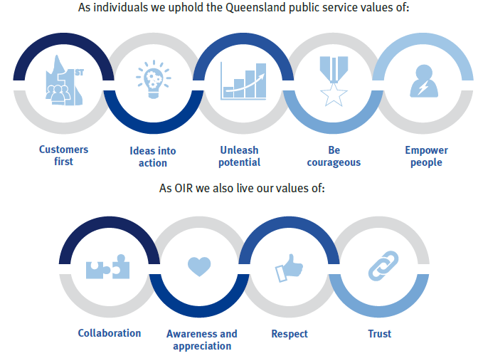

More information on OIR’s functions, focus and the type of organisation we are, can be found on the website https://www.oir.qld.gov.au/
Next steps
The selection process will start with short-listing, where we assess the information provided in your application. Based on this, we will select applicants to proceed to the next phase of assessment, which could involve phone screen, work test, interview or another selection technique. In some cases, there may be multiple phases of assessment.
Referee checking and other pre-employment checks will occur prior to any offer of employment. Checks may include (but are not limited to) criminal history and serious discipline history disclosure checks.
We will keep you up to date with the progress of your application and if you have any questions, please reach out to the contact person.
Additional information
- Employment conditions are set out in the Department of Education Certified Agreement 2022 and Queensland Public Service Officers and Other Employees Award – State 2015.
- OIR values diversity and cultural capability and is an equal opportunity employer which supports a healthy working environment.
- A mobile, flexible and agile workforce supports service delivery and employee development. You may seek or may be required to work in alternative locations or undertake alternative duties on a temporary or permanent basis.
- Applications will remain current for a period of up to 12 months and may be considered for other vacancies (identical or similar) which may include an alternative employment basis (temporary, full time or part time).
- Within one month of commencing employment, the successful applicant is required to disclose any employment as a lobbyist in the preceding two years.

