Principal Inspector (Industrial) – (Continuous Applicant Pool) (AO6)
 | Role type  Flexible, permanent full-time |  | Contact  cfsemp@oir.qld.gov.au
 | Salary per annum  $114,114 to $121,876*  *plus up to 12.75% superannuation contributions |  | Job ad reference  QLD/557916/24
 | Location  Any OIR Office |  | Closing date  Continuous Applicant Pool (closing Monday, 14th April 2025)
 | This role is open to all applicants; however we encourage applications from people with diverse backgrounds including Aboriginal peoples and Torres Strait Islander peoples, people with disability, people from culturally and linguistically diverse backgrounds and/or women.
Would you like to be part of a team that improves work health and safety in Queensland and helps to reduce the risk of workers being killed or injured on the job?
As part of a multi-disciplinary team, Principal Inspectors (Industrial) work with industry to improve health and safety in Queensland workplaces.
This position plays an important role in the implementation of the Best Practice Review of Workplace Health and Safety Queensland and ensuring we meet the expectations of compliance and enforcement that the community expects of us as a regulator.
What you can expect in this role
Key responsibilities include:
- Utilise the powers appointed to inspectors according to the Work Health and Safety Act 2011 and the Electrical Safety Act 2002 to assist the government in meeting the objectives of these Acts.
- Participate in state-wide compliance campaigns such as safety blitzes and industry audits.
- Provide a high level site response to workplace fatalities, serious incidents and complaints in line with the powers appointed to Inspectors.
- Participate in workplace assessments in order to determine the degree of risk existing at a workplace and compliance to workplace health and safety standards.
- Assist in leading a team of inspectors in targeted assessment programs which monitor and assess compliance with workplace health and safety legislation and provide reports on team outcomes;
- Utilise departmental and regional protocols, processes and systems to prioritise complaints, incidents, and other work.
- Assist in the allocation of work such as investigations, complaints and assessments to inspectors in an equitable manner within a team environment to achieve targets within set timeframes;
- Produce reports and conduct reviews of technical information arising out of serious workplace incidents.
- Participate in the professional development of inspectors in a team environment by adopting a training mentoring and coaching role in their work activities, providing guidance and performance conversations as required.
- Provide operational and specialist technical direction, support and advice to local staff in accordance with procedures, objectives and performance standards adopted by the department, and become personally involved in the more difficult or potentially contentious cases/issues.
- Liaise with local stakeholders in industry, commerce, government, education, training and the wider community to identify on-going and emerging needs and issues and provide advice to the Regional Operations Manager and the Director on these matters.
- Implement departmental procedures and policies with respect to human resource management, in particular, equal employment opportunity, performance planning and review and workplace health and safety.
- Actively participate in the promotion of a discrimination free workplace culture that values equity and diversity.
Our workforce needs to be agile to respond quickly to new and emerging priorities. You may be required to undertake alternative duties or work in alternative locations on a temporary or permanent basis to support service delivery.
You will receive competitive salary and benefits, generous leave entitlements, flexible work options and career progression opportunities.
What we are looking for
We will confirm your right to work in Australia and look at the extent to which you have the abilities, aptitude, skills, qualifications, knowledge, experience and personal qualities relevant to the role. We may also consider the way you have carried out previous employment or occupational duties, potential for you to make a future contribution to the Office of Industrial (OIR) and how you contribute to our obligations of equity, diversity, respect and inclusion.
Mandatory qualifications or conditions | - While there are no mandatory qualifications for this role, a degree is desirable but not required to perform this role.  - A current driver’s licence; or be able to acquire one  - Computer skills necessary to accurately and efficiently input and retrieve data on Workplace Health and Safety Queensland’s event and investigations databases, or be able to rapidly acquire.  - Completion of Workplace Health and Safety Queensland’s new inspector induction program and a minimum of six months field based to successfully complete the Diploma of Government (Workplace Inspection);  - Consent to necessary immunisations for the position should you be required to inspect workplaces where there is a risk of exposure to pathogens.  - Consent to the mandatory requirement of respiratory protective equipment (RPE) fit testing  - Participate in on-call and weekend roster work.
Core capabilities | Role competencies are aligned with the Leadership competencies for Queensland under the leadership stream: Individual contributor.
Role specific capabilities | - Demonstrated experience in mentoring teams and supporting others, preferably in a regulatory environment, to achieve desired outcomes in high pressure environments;  - Demonstrated high level interpersonal, consultative, written, and negotiation skills with an ability to effectively communicate with staff and a range of external client groups;  - Demonstrated ability to apply contemporary occupational health and safety legislation and apply risk management principles across a broad spectrum of hazards in contemporary work environments; and  - Demonstrated record of achievement in the management of occupational health and safety related projects in a team environment requiring significant planning, analysis and implementation.
How to apply
Please apply online through the Smart Jobs and Careers website. Go to www.smartjobs.qld.gov.au and access ‘Apply online’. Create a ‘My SmartJob’ account before submitting your application.
Your application needs to include:
- your current resume, including:
  - the name and contact details of at least one referee who has thorough knowledge of your conduct and performance within the past two years
  - information to help us understand how you could contribute to enhancing equity, diversity, respect and inclusion at the OIR.
- a letter or statement (one to two pages) that outlines your ability to undertake any mandatory conditions or qualifications, core capabilities and any specific capabilities outlined above in ‘What are we looking for’.
Please let us know what we can do to help you participate in the recruitment process and ensure your needs for cultural safety or reasonable adjustments are considered.
If you experience any technical difficulties, please contact 13 QGOV (13 7468). All calls relating to the status of your application once the job has closed should be directed to the contact officer on the role description.
If you do not have internet access and you are unable to submit your application online, please contact OIR Human Resources on 07 3406 9943 to enquire about alternative arrangements.
Late applications cannot be submitted online, so please allow enough time before the closing date to submit your application. Requests for consideration to submit a late application can be made to the contact person for this role.
About us
OIR’s purpose is to deliver contemporary regulatory and other government services to Queenslanders and our vision is for Queensland workers, industry and communities to be healthy, safe, fair and productive. To achieve this, we are focused on three priorities:
Industry, community and partnerships | Regulatory standards | Our people
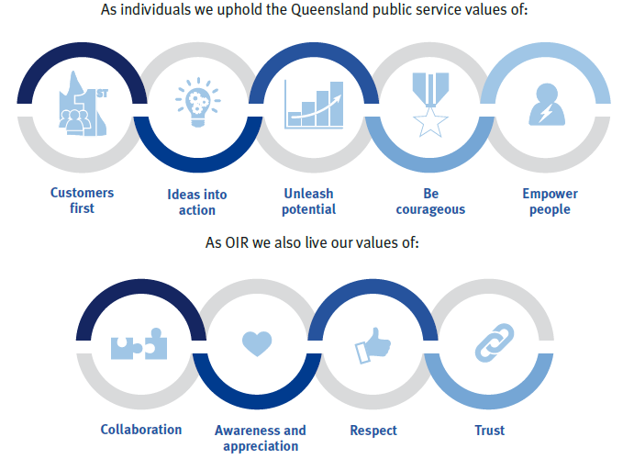

More information on OIR’s functions, focus and the type of organisation we are, can be found on the website https://www.oir.qld.gov.au/
Next steps
The selection process will start with short-listing, where we assess the information provided in your application. Based on this, we will select applicants to proceed to the next phase of assessment, which could involve phone screen, work test, interview or another selection technique. In some cases, there may be multiple phases of assessment.
Referee checking and other pre-employment checks will occur prior to any offer of employment. Checks may include (but are not limited to) criminal history and serious discipline history disclosure checks.
We will keep you up to date with the progress of your application and if you have any questions, please reach out to the contact person.
Additional information
- Employment conditions are set out in the Department of Education Certified Agreement 2022 and Queensland Public Service Officers and Other Employees Award – State 2015.
- OIR values diversity and cultural capability and is an equal opportunity employer which supports a healthy working environment.
- A mobile, flexible and agile workforce supports service delivery and employee development. You may seek or may be required to work in alternative locations or undertake alternative duties on a temporary or permanent basis.
- Applications will remain current for a period of up to 12 months and may be considered for other vacancies (identical or similar) which may include an alternative employment basis (temporary, full time or part time).
- Within one month of commencing employment, the successful applicant is required to disclose any employment as a lobbyist in the preceding two years.

