Working for Queensland Revenue Office

Thank you for your interest in applying for a position with Queensland Revenue Office (QRO). QRO is a division within Queensland Treasury. We are committed to the values of the Queensland Public Service and to recruiting, retaining, and developing a workforce that supports QRO now and in the future.

The information is designed to provide you with a better understanding of our purpose, vision, mission, values, and workplace culture when deciding to apply for an opportunity with us. Please refer to the Candidate Information Pack for important additional information relevant to working in Queensland Treasury.

More about QRO
We contribute over $35 billion revenue from collecting taxes & royalties, paying grants, issuing, collecting and enforcing fines. This money goes back into roads, schools, hospitals and health services, as well as other Government services.

To find out more about our services visit About QRO - Queensland Treasury and State Penalties Enforcement Registry - Queensland Treasury.
As an employee of QRO, you'll be part of a dynamic and collaborative culture, working alongside talented, supportive and passionate people, to help us ultimately grow our economy and improve the wellbeing of all Queenslanders.
Building a career with us means you can help make a real difference in the lives of Queensland workers and employers, and their families.
We share the responsibility for career and skill development of our workforce, and we provide many opportunities for internal mobility to provide you with a career lattice, not just a ‘ladder’.
Here at QRO, we've planned for success. To guide us on that journey, we've developed our purpose, vision, strategic objectives and values statements which articulate what we're out to achieve and how we'll get there.

Our Purpose
We contribute to Queensland’s economic and social wellbeing by collecting revenue, recovering debt, and paying grants.

Our Vision
To make complying effortless while optimising revenue for Queensland.

Our Strategic Objectives
Our strategic objectives are forward looking actions that focus attention on what matters most to our success.

Client experience: Make it easy for people to meet their obligations and receive their entitlements.
Trustworthiness: Deliver impartial and efficient services that instil community trust.
Better services: Enhance our services including through the use of digital tools and data-driven insights.
Our people: Develop a capable, change-responsive, and collaborative workforce.
Expertise: Strengthen our expertise in risk-based revenue management and the interpretation and application of law.

Additional information about the role
- This role is based in QRO’s Southport office on the Gold Coast.
- Working in a positive and productive team environment, you will conduct and manage debt recovery activities to effectively collect overdue revenue, taxation, and penalty debts within a legislative environment.
- This role will see you working directly with an extensive range of stakeholders within and external to QRO.
- We are focused on enhancing the experiences of clients, staff and other stakeholders through collaboratively designed processes and implementing e-business initiatives.
- Limited travel may be required between QRO offices.
- A probation period of three months may apply.
Our office locations
QRO currently has several office locations in southeast Queensland and provides a range of client services/ functions from each location.

QRO currently has work locations in:

- Brisbane CBD
- Ipswich
- Maroochydore, and
- Southport

Opportunities exist to move around the organisation and locations to build your skills base across our range of services through expressions of interest to transfer at level, and ongoing recruitment.

Our QRO Values
Our values have been developed in the context of the Queensland public sector values, and guide how we do our work, operate as an organization, treat our customers and each other.

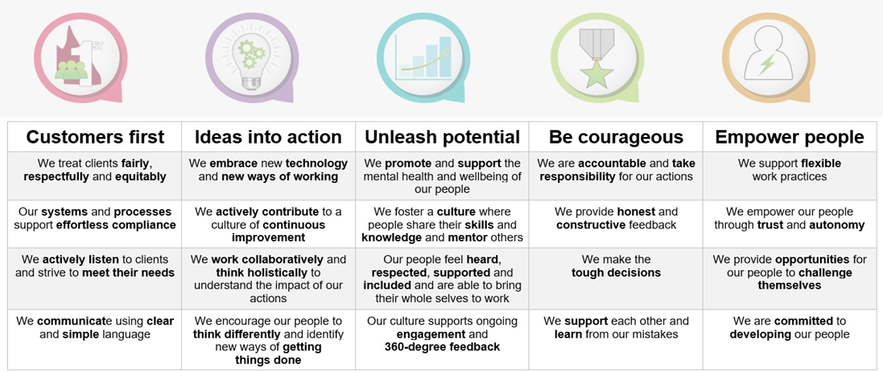

QRO’s behavioural expectations
At QRO, we believe that building a constructive culture is key to achieving our strategic and organisational objectives. We believe that everyone is responsible for creating this culture and modelling constructive behaviours. We have identified what these behaviours look like and use the S T E P approach to understand how we can live them.

Encouraging is about Support

People at QRO should feel supported and encouraged to develop themselves and others. That means you should constructively inspire those with whom you interact with.

- Ask insightful questions designed to help others arrive at their own solutions and subsequently build others’ problem-solving skills and confidence.
- Involve others in the decision-making process whenever possible.
- Allow people to take pride of ownership in a project.
- Encourage others to take calculated risks and be there to support their efforts. Give your full attention and consideration to their ideas.
- Show faith in others’ abilities to improve themselves, and actively support their efforts.
- Encourage others to set goals for themselves and to help QRO grow through their own involvement.

Affiliative is about Trust

People at QRO should feel trusted and trust others. That means you should emphasise teamwork and value others who work well with each other, create a co-operative spirit, share information, and provide legitimate praise.

- Demonstrate concern for others and their needs; and be tactful and considerate of others’ feelings.
- Motivate others using genuine praise and friendliness.
- Seek out, establish, value, and maintain close associations with others.
- Share thoughts and feelings easily and help others to feel important and worthwhile.
- Communicate your sociability by smiling often and making eye contact.
- Strike up conversations with others you do not know.

Achievement is about Excellence

People at QRO should know what excellence is and always do their best to achieve it. That means you should encourage those you interact with to give their best effort on all the work they do, and lead by example.

- Set and communicate challenging yet realistic performance standards, rather than goals imposed by others.
- Promote teamwork by consistently seeking others’ input; share responsibility and build others’ confidence.
- Value and promote others who are innovative self-starters.
- Encourage achievement-oriented thinking; help others discover for themselves.
- Take advantage of opportunities to give and receive constructive feedback.
- Ask others for input on what QRO can do to become more forward thinking.

Self-actualising is about Potential

People at QRO should be curious, enjoy what they do and pursue opportunities to reach their potential. That means you should see the possibilities and opportunities in most situations, take ownership and pursue them with enthusiasm.

- Take an open-minded flexible approach to your work.
- Identify and develop realistic long-term goals and approach problems positively and solve them creatively.
- Respect the abilities and talents of others and actively encourage working together toward a project’s success.
- Balance concern for getting the job done with consideration for people and their needs.
- Take pleasure in what you do and be spontaneous.

Workforce Talent Management
At QRO we are committed to providing development pathways to support your career.

We offer a range of targeted programs for: emerging leaders, first nations peoples, leadership development, mobilising employees within QRO, QT and/or other government agencies, succession planning, and talent skill development.

