Role Description
Enrolled Nurse
- Reference: | - TV537603 | - Position ID: | - 30463601
- Role title: | - Enrolled Nurse | - Classification: | - Nurse Grade 3
- Employment status: | Permanent part-time and full-time  (Minimum part-time hours are  16 hours per fortnight) | - Salary: | $2650.90-$2813.40  per fortnight (full-time)  $34.88-$37.01 per hour  (part-time)
- Unit/ Branch: | Nursing and Midwifery Workforce Services,  Corporate Services | - Contact Name: | - Nursing and Midwifery Workforce Services
 |  | - Contact Number: | - 07 4433 4954
- Location: | - Townsville | - Closing Date: | - Wednesday 8 January 2025
The Opportunity
The Enrolled Nurse (EN) provides person centred nursing care under direct and indirect supervision of the Registered Nurse (RN) and in accordance with the Practice Standards as identified by the Nursing and Midwifery Board of Australia (NMBA). The EN will work within a multidisciplinary team to deliver quality cares for patients, residents, and consumers and their family in accordance with relevant standards, procedures, and instructions. EN’s will work within Nursing and Midwifery Staffing Team (NMST) to provide support to different clinical areas within the health service.
Reporting line, staffing, and budget responsibilities
- This position reports operationally to the Nurse Manager, Nursing Midwifery Workforce Services (NMWS).
- All nursing and midwifery positions report professionally through the relevant Service Group nursing and midwifery structure to the Executive Director of Nursing and Midwifery.
The role
Autonomy:
- Practises under the direct or indirect supervision of a registered nurse/midwife assisting with the care of recipients of healthcare services as delegated by the registered nurse/midwife.
- Seeks assistance and support in decision making from a registered nurse/midwife.
Responsibilities:
Domain 1: Direct comprehensive care
- Accountable for Nursing and Midwifery Board of Australia (NMBA) and own standards, actions and the outcomes of own nursing/midwfery practice and supervision of unregulated healthcare workers.
- Provide direct and indirect care, engage in reflective and analytical practice and demonstrate professional and collaborative practice.
- Consolidate educational preparation and increase knowledge and skills while moving from beginner to experienced.
- Collaborate and consult with healthcare recipients, their families and community as well as registered nurses/midwives and other health professionals, to plan, implement and evaluate nursing care.
Domain 2: Support of Systems
- Adhere to developing, reviewing and evaluating clinical/nursing standards, guidelines, protocols, pathways, procedures, standards and systems of work as set out by the organisation.
- Maintain the safety of recipients of healthcare by identifying risk and undertaking safe work activities within the clinical practice environment.
- Engage in incident reporting and participate in quality improvement activities to promote safe and/or rectify unsafe practice.
- Participate with other members of the healthcare team in providing support and mentorship to new and less experienced staff.
Domain 3: Education
- Contribute to quality healthcare through lifelong learning and professional development of self and others.
- Provide health promotion and education to recipients of healthcare services and carers.
Domain 4: Research
- Participate as appropriate in evaluative and local action research activities.
- Apply evidence-based guidelines to achieve positive care outcomes for recipients of healthcare services as delegated by the registered nurse/midwife.
Domain 5: Professional Leadership
- Collaborate with the registered nurse/midwife in clinical and organisational governance.
- Under the guidance of the registered nurse/midwife work to achieve best practice outcomes within the work unit environment.
Additional:
- Fulfil the responsibilities of this role primarily in accordance with the Townsville Hospital and Health Service (HHS) core values, as outlined below, and in accordance with the values outlined for the public service with the Queensland Government.
- Ensure that service standards, safety and quality are maintained through adherence to defined service quality standards and relevant occupational health and safety policies, procedures and work practices.
- Implement and monitor the organisation’s quality standards, occupational health and safety policies, procedures and programs and provide clinical governance in the relevant work area.
- Some roles within Queensland Health are designated as Vaccination Preventable Disease (VPD) risk roles.
This is a VPD risk role.
Work Health and Safety
Townsville HHS is committed to providing a safe workplace for all employees. This commitment includes a dedicated People Focussed Safety culture.
A People Focussed Safety culture commits to the health, safety and wellbeing of staff, volunteers and other persons, through the provision of a dynamic and comprehensive Health and Safety Management System (HSMS). The HSMS provides for proactive safety initiatives, early injury management practices with a strong focus on a safe and durable return to work.
The provision of a Health and Safety environment within Townsville HHS is everyone’s responsibility.

Safety and Quality
Relevant to the position, participate in the ongoing education, implementation, monitoring and evaluation of safety and quality initiatives set by The Australian Commission on Safety and Quality in Health Care to achieve a safe high-quality and sustainable health system, including compliance with the National Safety and Quality Health Services Standards.
Relevant to the position, participate in the ongoing education, implementation, monitoring and evaluation of safety and quality initiatives relevant to Aged Care Quality and Safety Commission, Aged Care Quality Standards and the National Disability Insurance Scheme Practice Standards.
Relevant to the position, participate in the ongoing education, implementation, monitoring and evaluation of safety and quality initiatives relevant to The National Safety and Quality Health Service (NSQHS) Standards, Multi-Purpose Services Aged Care Module and the National Disability Insurance Scheme Practice Standards.
For more information in regards to Work Health and Safety Accountabilities within the Townsville HHS please review Workplace Health and Safety Act 2011 - Part 2, Health and Safety Duties.
Mandatory qualifications/ professional registration/ other requirements
- Qualification: Diploma of Nursing or equivalent certification relevant to the position is mandatory.
- Nursing: Appointment to this position requires proof of qualification and registration with the Australian Health Practitioner Regulation Agency (AHPRA) and possession of a current practising certificate. Certified copies of the required information must be provided to the appropriate supervisor/manager prior to commencement of clinical duties.
- Highly Desirable: Evidence of completion of modules related to medication administration and peripheral intravenous therapy.
- Shift Workers: Appointees will be required to work all shifts in accordance with the unit roster.
- Aged Care Pre-Employment Screening: Applicants are advised this position works in an identified Aged Care Facility as per the Aged Care Act 1997 and therefore requires employees and volunteers to have a current National Police Certificate. Queensland Health will facilitate applicants obtaining the above National Police Certificate.
- National Disability Insurance Scheme (NDIS) Worker Screening Check: As a Health Care worker in Queensland Health who engages in risk-assessed roles, you must hold a current disability check (Yellow Card or Yellow Card Exemption) or a NDIS worker screening check, in accordance with Part 5 of the Disability Services Act 2006 (Qld).
- Vaccine Preventable Disease (VPD): Health Care Workers in Queensland Health whose occupation poses a potential risk of exposure to blood or body fluids are required to provide evidence of vaccinations or proof that they are not susceptible (due to prior exposure to the disease and therefore have natural immunity) to the following VPD's Hepatitis B, Measles, Mumps, Rubella, Varicella and Pertussis (diphtheria, tetanus and pertussis containing vaccine) according to the Queensland Health Policy.
How you will be assessed
You will be assessed on your ability to demonstrate the following key requirements, knowledge and experience which is outlined under ‘The role’. The ideal applicant will be someone who has proven ability and can demonstrate the following:
- Ability to contribute to assessment, planning, implementation and evaluation of person centred nursing care under the delegation of the registered nurse/midwife.
- Ability to work as an effective member within a multidisciplinary team.
- Ability to effectively communicate verbally and in writing with the multidisciplinary team, patients and their families.
- Ability to use or learn to use information systems appropriate to the position.
- Ability to demonstrate own ongoing professional development.

Your Application
Please provide the following information to the panel to assess your suitability:
- Your current CV or resume, including referees. You must seek approval prior to nominating a person as a referee. Referees should have a thorough knowledge of your work performance and conduct, and it is preferable to include your current/immediate past supervisor. By providing the names and contact details of your referee/s you consent for these people to be contacted by the selection panel. If you do not wish for a referee to be contacted, please indicate this on your resume and contact the selection panel chair to discuss.
- A short response (maximum of two pages) on how your experience, abilities, knowledge and personal qualities are relevant for the role, taking into account the key responsibilities and key attributes of the position.
- Applications will remain current for 12 months after they have been submitted.
- Future vacancies of a similar nature throughout the Townsville Hospital and Health Service may also be filled through this recruitment process.
Once completed, your application should be submitted online – visit www.smartjobs.qld.gov.au. If you have difficulties, please contact Recruitment Services on 1300 193 156.
About the Townsville Hospital and Health Service
The Townsville Hospital and Health Service (HHS) is the public healthcare provider for more than 250,000 people across a geographic area of 150,000km².
We serve the local government areas of Townsville, Burdekin, Charters Towers, Flinders, Richmond, Hinchinbrook and Palm Island.
In doing so, we operate 21 facilities: 19 hospitals and health centres and two residential aged care homes. More than 6,600 staff work across our facilities, which is about one in every 17 working people, making us members of the communities we serve.
We provide a comprehensive range of services, from primary care in remote locations, to highly specialised care at Townsville University Hospital. This is the largest tertiary hospital in Northern Australia, providing specialist referral services for the 700,000 people living from Mackay to the Torres Strait, to the Northern Territory border.
More than providing the healthcare of today, we are planning and innovating for the future. Our staff and collaborators are advancing healthcare through impactful research. While as a major teaching hospital, we are training tomorrow’s doctors, nurses, midwives, allied health practitioners, and more.
Our vision is world-class healthcare for northern Queensland. The Townsville Hospital and Health Service Strategic plan 2022-2026 commits to this ambitious direction, outlines our strategic objectives and lists the measures we will use to know we have achieved them.
Person Centred Care is an essential part of Townsville HHS. Our patients are central to everything we do and we recognise the importance of their families and carers. We appreciate the importance of all our staff and support them to deliver person centred care.
Cultural capability principles are supported by the Townsville HHS to be embedded into all nursing and midwifery practice. Cultural practice training is a key requirement to ensure we provide culturally capable workforce to enhance the patient journey.

Our Vision: World-class healthcare for northern Queensland
Our Purpose: Great care every day
Our Values:
Please visit our website for additional information about the Townsville Hospital and Health Service

Health Equity and Racism
Townsville Hospital and Health Service has set out its actions and agreed key performance measures to improve Aboriginal and Torres Strait Islander people’s health and wellbeing outcomes. The Health Equity Strategy and Implementation Plan can be found at First Nations Health Equity Strategy 2022-2025 and Implementation Plan
Racism is a key structural determinant of Aboriginal and Torres Strait Islander people’s health inequity. Racism is not always conscious, explicit, or readily visible - often it is systemic. Systemic or institutional racism are forms of racism that are widely and deeply embedded in systems, laws, written or unwritten policies and well-established practices and beliefs that produce, condone, and perpetuate widespread unfair treatment, causing and/or contributing to inherited disadvantage.
It is expected that all Townsville Hospital and Health Service staff, including the incumbent of this role as a valuable member of the Townsville Hospital and Health Service workforce, contribute to the health equity agenda and meet the intent of supporting the defined six actions that specifically meet the needs of Aboriginal and Torres Strait Islander people within the National Safety and Quality Health Service Standards (NSQHS), by actively supporting the elimination of racial discrimination and institutional racism; supporting increased access to health care; influencing the social, cultural and economic determinants of health; supporting the delivery of sustainable, culturally safe and responsive health services; and recognise the importance of working with Aboriginal and Torres Strait Islander peoples, communities and organisations to design, deliver, monitor and review the health and support services we provide.
Additional Information
- Pre-employment screening, including criminal history, aged care checks, and discipline history checks, may be undertaken on persons recommended for employment. Roles providing health, counselling and support services to children will require a ‘working with children check’ from the Blue Card Services Department of Justice and Attorney-General prior to appointment, unless otherwise exempt.
- Employees who are permanently appointed to Queensland Health may be required to undertake a period of probation appropriate to the appointment.
- All relevant health professionals, who in the course of their duties formulate a reasonable suspicion that a child or youth has been abused or neglected in their home/community environment, have a legislative and a duty of care obligation to immediately report such concerns to Child Safety Services, Department of Communities.
- Applicants will be required to give a statement of their employment as a lobbyist within one (1) month of taking up the appointment. Details Lobbyist Disclosure.
- Applicants may be required to disclose any pre-existing illness or injury which may impact on their ability to perform the role. Details are available in section 571 of the Workers' Compensation and Rehabilitation Act 2003.
- In accordance with Government requirements and Queensland Health’s commitment to a healthier workplace the Queensland Health Smoking Management Policy supports a smoke-free environment. Smoking is prohibited at all Queensland public hospitals and health facilities and for five (5) metres beyond their boundaries. Queensland Health employees may obtain assistance to quit smoking through staff program Quit Smoking for Life program. Information is available at Quit smoking.....for life!

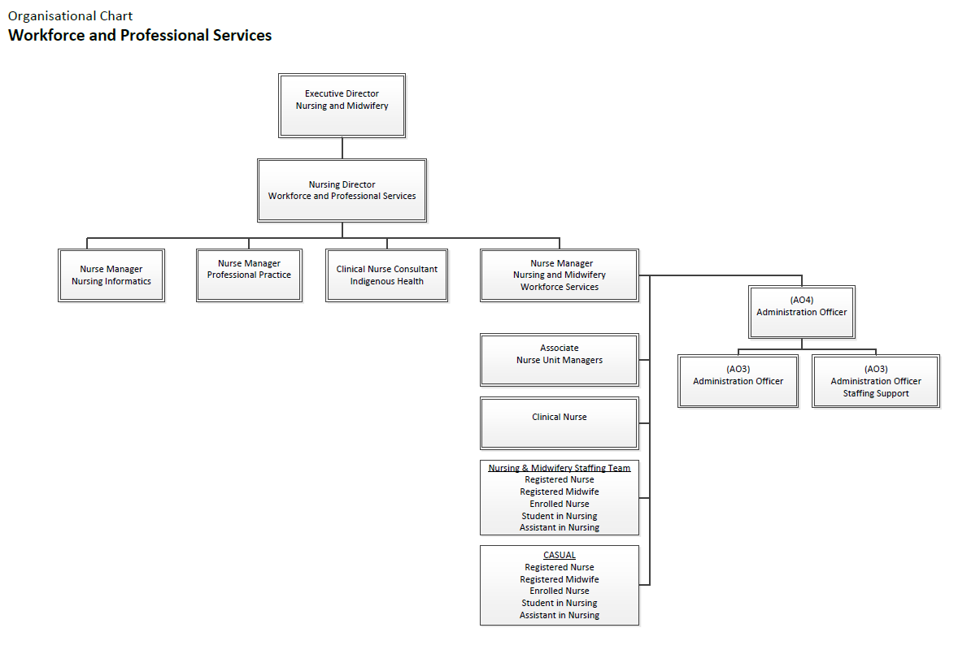
Organisational Chart

